Small Seeds growing to ….?

Rev’d Charlotte Bannister-Parker at
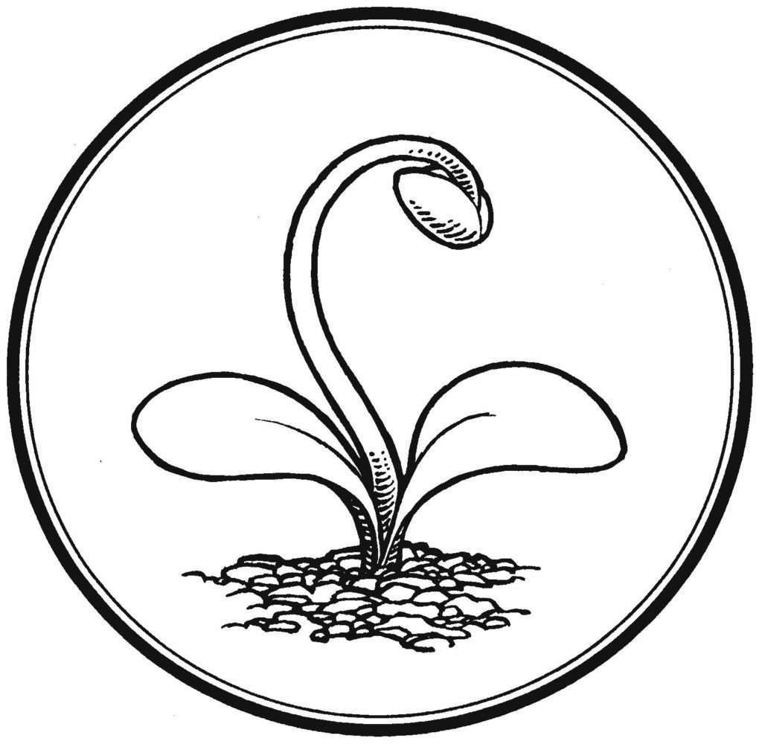
The University Church of St Mary the Virgin, Oxford. June 2018

Mark 4: 26-32
(The Parable of the Growing Seed)
He also said, “This is what the kingdom of God is like. A man scatters seed on the ground. Night and day, whether he sleeps or gets up, the seed sprouts and grows, though he does not know how. All by itself the soil produces grain—first the stalk, then the head, then the full kernel in the head. As soon as the grain is ripe, he puts the sickle to it, because the harvest has come.”
(The Parable of the Mustard Seed)
Again he said, “What shall we say the kingdom of God is like, or what parable shall we use to describe it? It is like a mustard seed, which is the smallest of all seeds on earth. Yet when planted, it grows and becomes the largest of all garden plants, with such big branches that the birds can perch in its shade.”

Ezekiel 17: 22-24
“This is what the Sovereign Lord says: I myself will take a shoot from the very top of a cedar and plant it; I will break off a tender sprig from its topmost shoots and plant it on a high and lofty mountain. On the mountain heights of Israel, I will plant it; it will produce branches and bear fruit and become a splendid cedar. Birds of every kind will nest in it; they will find shelter in the shade of its branches. All the trees of the forest will know that I the Lord bring down the tall tree and make the low tree grow tall. I dry up the green tree and make the dry tree flourish. “I the Lord have spoken, and I will do it.’”
_____
May I speak in the name of the Father, Son and Holy Spirit.
I have a confession to make. Recently, I have been struggling with guilt brought about because of my overuse of plastic items on a daily basis. This guilt was mainly prompted by the things that all of us have seen in the recent years on social media and the internet; photographs and videos of melting glaciers, floating icecaps, giant fish washed up on shores after consuming plastic waste dumped in the oceans and so on. Sometimes in life, we are presented with an image that we find so arresting or disturbing that it seems to shock us into seeing things differently.

One such image, is the photograph below, of a seahorse wrapped around a Q-tip, which was sent to me last week by a colleague. This magnificent yet horrifying photograph was taken in 2016 in the seas of the Indian archipelago. It’s a photo that I, just like the photographer, wish did not exist. But since it unfortunately does exist, I want everyone to see it.
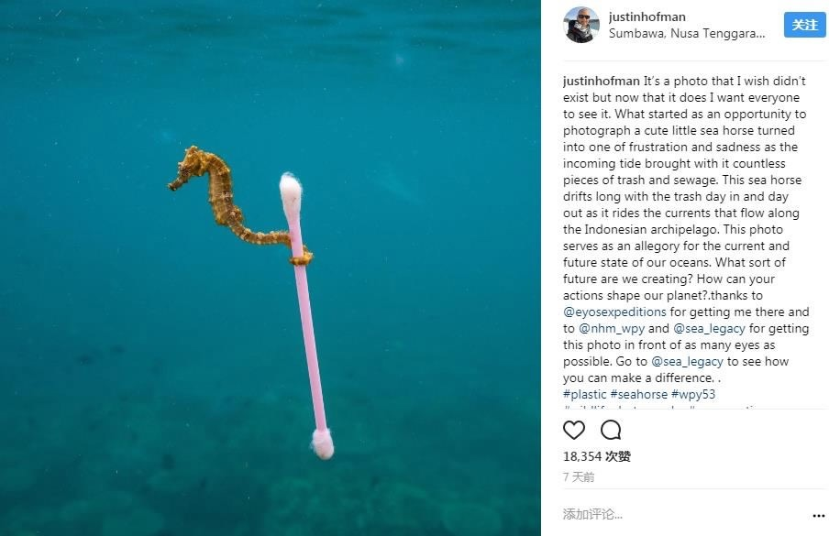
When photographer Justin Hofman snapped this photo while snorkeling off the coast of the Indonesian island of Sumbawa in 2016, he couldn't have imagined the environmental and social impact the snapshot would have. A year later, this particular photograph became a finalist in the Wildlife Photographer of the Year competition and has been dubbed the “poster child for today’s marine trash crisis.” Hofman was gleefully watching the seahorse bounce from natural object to natural object, hitching rides on the current, when something changed. Here’s a piece of the official image caption:

“As the tide started to come in, the mood changed. The water contained more and more decidedly unnatural objects- mainly bits of plastic- and a film of sewage sludge covered the surface. The seahorse let go of a piece of seagrass and seized a long, wispy piece of clear plastic. As a brisk wind at the surface picked up, making conditions bumpier, the seahorse took advantage of something that offered a more stable raft: a waterlogged plastic cotton swab.”

When Hofman shared the photo on his Instagram account, it received immediately 18,000 likes and 1,100 comments. But it’s a photograph that Hofman wishes didn't exist. “The seahorse drifts along with the trash, day in and day out, as it rides the currents that flow along the Indonesian archipelago,” he wrote on Instagram. “This photo serves as an allegory for the current and future state of our oceans.”

I see this photograph as a visual parable; an arresting image just like the way Jesus uses impressive natural images to get his message across about the nature of the kingdom of God. Just like the parable of a mustard seed which Jesus narrated to a poor, rural, farming community to illustrate the Kingdom of God, he gave his followers other, similar stories to make them understand what God’s reign on earth would look like. Jesus built on his knowledge of the words of the prophet Ezekiel and the strong power image of the cedar tree presented by him. Ezekiel delivered his message to the Jews as they were being taken captive into the foreign country of Babylon. God was allowing this to happen because of their refusal to repent their sins, primarily idolatry. It wasn't a very joyous time but God gave a promise of future deliverance to His people in the midst of this time and sorrow.

In Ezekiel 17:22-24, God says, “I myself will take a shoot from the very top of a cedar and plant it; I will break off a tender sprig from its topmost shoots and plant it on a high and lofty mountain.” God plants a tiny cedar twig so high so that we can see the image of a shrub so big and large that every kind of bird can shelter under it: the tall cedar tree. These items were awe-inspiring and spoke of the grandeur of God’s creation. In the Old Testament, they are associated with both the majesty of earthly kinds as well as God’s majesty.

There are two possible interpretations for this. Some theologians believe that furthermore, when He says in verse 23, “birds of every kind will nest in it,” that God here was foretelling His plans for the coming of Christ. This is indeed a Messianic prophecy being fulfilled in the Lord Jesus. There are others who think that the birds might symbolise the nations that flock to Israel’s God on the glorious day of the Lord.

Jesus told parables to help people visualise what it was going to be like. (Refer to Mark: 9, Matthew 13: 31-32 and Luke 13: 18-19). But, why use an item like a mustard seed? It was a tiny, insignificant and relatively unimportant thing and it wasn’t a highly prized item. Jesus chose the mustard seed for exactly this reason. He used the mustard seed in the parable to show that even something as small as a mustard seed can have miraculous powers within it. Think about it. A seed not much bigger than a pinhead has within it the power to become a towering yellow plant. Just as a small idea, a single thought, a tangible act can start you on your path to becoming a vibrant disciple of Jesus.

A mustard bush grows like a weed, very fast and very powerful. As in Luke 17:6 and Matthew 17:20, we see how small the size of a mustard seed is proverbial in the fact that it expresses greatness and rapid growth. But this parable is not just about growth. It also points to the nature of God’s kingdom on earth and shows to all those listening some important characteristics of it. The kingdom being experienced at that time was one of oppressive rule, under Herod and ultimately under Caesar. Jesus points to the good news of an alternative kingdom: The Kingdom of God. Jesus is in a way is asking how God would rule the world if He sat on Caesar’s throne? Or for us now
what life would be like on earth if He was king?

Some of the characteristics of the Kingdom of God?

1. God’s kingdom starts small: Dr. R.C Trench was an Irish pastor in the 1800’s wrote the following words concerning God’s kingdom: “The Son of Man was born in obscurity and grew up in a despised province. He did not appear in public until his thirtieth year; then taught for only three years in neighbouring villages, and occasionally in Jerusalem. He had only a few followers, chiefly among the poor and unlearned. Then falling into the hands of His enemies, He died a shameful death on a cross. Thus was the commencement of the Kingdom of God.” This is a small beginning.

2. God’s kingdom grows steadily: Jesus continued, “Yet when planted, it grows and becomes the largest of all garden plants.” (Mark 4:32). The mustard plant can grow to a height of fifteen feet. That’s a huge plant from such a tiny seed. The same is true of the Kingdom of God. From the tiny beginning of the kingdom in a manger in Bethlehem, God’s kingdom has grown remarkably. The Church of the Lord Jesus which started with only a few people has grown into a global family. It is amazing to reflect on the small, humble beginnings of one man, one ministry and one place to what has now become a global religion of 2.1 billion believers.

3. God’s kingdom is one of protection and shelter. The Bible says, “For the kingdom of God is not a matter of eating and drinking, but of righteousness, peace and Joy in the Holy Spirit.” (Romans 14:17) God’s kingdom offers shelter: Jesus described the mustard plant as, “...with such big branches that the birds of the air can perch in its shade.” (Mark 4:32) As I have seen in Israel, it is not unusual to see small birds landing on the branches of the mustard plant; some even build nests in them. There is a spiritual application here. Just as the mustard seed provides shelter for the birds, we find protection and shelter in God’s kingdom. The Bible says, “He who dwells in the shelter of the Most High will rest in the shadow of the Almighty.” (Psalm 91: 1)

I am reminded of Blake’s poetry here. The opening reflection of the poem contains very well-known lines. The metaphorical imagery used by Blake reminds us that the small, seemingly insignificant “grain of sand” or “wild flower” can hold universal beauty and importance.
To see a World in a Grain of Sand
And a Heaven in a Wild Flower,
Hold Infinity in the palm of your hand
And Eternity in an hour.
To See a World…

In Blake’s poem ‘The Auguries of Innocence’, the themes explored are the principles of freedom and equality. Blake’s poetry often rebelled against the injustices of rigid class systems and the hypocrisy inherent in organised religion at the time. These themes continue as Blake illustrates examples of man’s careless treatment of creatures who are at his mercy. He describes how “He who shall hurt the little Wren/Shall never be beloved of men” and how “He who the Ox to wrath hath mov’d, Shall never be by woman lov’d.” Lines such as these reinforce the idea that all of life can be seen through nature, as seen in the opening lines, and that man has a responsibility not to treat nature thoughtlessly but rather must nurture and appreciate it. Securing the protection and safely of man and nature is key.

This apocalyptic imagery seems to reflect Blake’s belief that mankind must stop these injustices or there will be dire consequences for society and humanity. The poem can also be viewed as a stark warning about the inevitable consequences for society when there is wanton mistreatment of people and nature. It is almost as if Blake has a futuristic vision of Hofman’s photograph of the seahorse and the Q-tip he instinctively knew the potential treat our planet would face if we failed to heed to the vision for the Kingdom of God where we honored and protected our natural environment. Often in times of turmoil I turn to reading The Beatitudes.

"Blessed are the poor in spirit, for theirs is the kingdom of heaven.
Blessed are they who mourn, for they shall be comforted.
Blessed are the meek, for they shall inherit the earth.
Blessed are they who hunger and thirst for righteousness, for they shall be satisfied.
Blessed are the merciful, for they shall obtain mercy.
Blessed are the pure of heart, for they shall see God.
Blessed are the peacemakers, for they shall be called children of God.
Blessed are they who are persecuted for the sake of righteousness,
for theirs is the kingdom of heaven."

which tell of what life would be like on earth if “the coming of God’s kingdom” is realized. It means food for the hungry. “They will be filled.” The scripture points to being without debt and with enough food to eat. “Blessed are you who are poor, for yours is the kingdom of God, Blessed are you who are hungry now, for you will be filled.” (Luke 6:20) God’s kingdom is both here and now and will come. But the theologian Steven Chase in his book Nature as a Spiritual Practice says that one can also use the Beatitudes as a model “ for growth in communion and love of nature”. He encourages the seeker to “ Notice how each Beatitude can be applied to the natural world. Or to put it another way, imagine the Beatitude as a special pair of glasses through which you observe nature.
For example, the first Beatitude in Matthew 3:3 is “Blessed are the poor in spirit, for theirs is the Kingdom of heaven”. Observe or walk through nature, watching for what you see or experience as ‘poor in spirit’. This could be a dying or degraded part of nature or what would it mean to be ‘poor in spirit’ in your interaction and connection with nature?” What Chase is pointing to reading scripture, the Beatitudes the lord prayer as a is the method to help us meditate on creation, contemplate on nature and enable us to see God in all things - so we begin to respond to nature on earth as it is. ‘For Thy will be done, on earth as it is”. (Matthew 6:9–13).

So what is happening on earth as it is?

Yesterday the Bishop of Salisbury, Nick Holtan put out a press release which said that, “More than 5,500 UK churches convert to renewable energy- diverting more than 5 million from fossil fuels by using 100% green electricity tariffs.” A miraculous turn around for the Church of England congregations and which illustrates a growing commitment to the development of eco-churches. Many more attention is being paid also to non-profit organizations which support such change. For example:
- Client Earth is an NGO that is getting increased attention. They are a group of lawyers committed to securing a healthy planet who use environmental law to protect oceans, forests and other habitats for people.
- The World Land Trust is another NGO, based in Suffolk, that I urge you to explore. They are an international conservation charity supported by Sir David Attenborough that strives to protect the world’s most biologically significant threatened habitats and funds the creation and protection of reserves. If you are looking for a direct carbon-offsetting scheme for your summer holiday flights or your general household emissions, donating to WLT is one of many excellent ways to do it.
- Here in Oxford, there is a new movement called Refill Oxford Water Fountain. I want to say a few words about Refill because it is local, practical and inspiring.

Refill Oxford

To help create a plastic free, sustainable environment in our city, Refill is working to install a series of business-funded (and hopefully artist-designed) water fountains in key places in Oxford. The plan is to have a refill point on every major street corner so that people can refill their water bottles, rather than buying a new one. These visible fountains will support the roll-out of a wider network of Refill stations inside retail premises in the city.

As Refill outlets, participating cafes, bars, restaurants, galleries, museums and other businesses will display a round, blue branded Refill sticker in their window to encourage people to come in and fill up their water bottles for free. There’s even a Refill app you can put on your phone. Everyone who lives, works or visits Oxford will be able to locate Refill stations easily. Why is this important? Worldwide, we drink 3.2 billion litres of bottled water per year. 420 million plastic bottles end up in landfill eventually. Bottled water production creates 500 times more CO₂ than tap water. If we continue as we are, there will be more plastic than fish in the sea by 2050.

The Refill scheme can reduce Oxford’s use of plastic bottles and waste at their source. We can do our part to cut waste, use less fuel and thereby cut our CO₂ emissions. This program also promotes well being in Oxford -- providing free, fresh, clean, running water for everyone. Success with Refill can help Oxford’s green credentials, and hopefully inspire other Refill schemes around the country.

Why and how can Oxford churches be involved?

As I hope I’ve highlighted today, the proliferation of plastic trash is a huge crisis. It is crazy that in places like Britain, like Oxford, where clean, fresh water is available for free, we buy millions of litres of less clean water in plastic bottles and then throw them away.

Churches in Oxford can lead by example in installing water fountains. Not only do we have physical structures, with plumbing, in lots of places where pedestrians pass, but I believe we have a moral duty to help people change their behaviour. If we can get SMV and other Oxford churches to be part of the first cohort of public drinking fountains that helps put Refill develop, that will be a very good thing. From such a start, who knows what impacts a church water fountain might have. In some cases maybe it would evolve into a ‘fountain of giving’ where church fountains give free water and individuals toss a coin into the fountain to give back to the church, in the same way that people put 50p in an honesty box to light a candle. Maybe it isn’t too optimistic to speculated that, over time, these water fountains could bring new audiences into church.

Therefore, to conclude, The Kingdom of God is what life would be like on earth if God were king. It is a dream for the creation and Jesus knew that it could be a reality. We still have a long way to go but like a mustard seed the potential is growth is huge. But our first steps should be towards changing our lifestyles to stop and reverse the damage we have done to the earth, the skies and the seas. As unsettling and depressing as we find Hofman’s image of the sea horse, there is always hope. From the tiny speck of a mustard seed can come a vast plant. From a modest start like building – and using – a water fountain instead of buying supermarket water in a plastic bottle, we can take a first step towards cleansing and restoring part of God’s creation. Amen.

Fragments from "Auguries of Innocence” by William Blake.
Matthew 5:3–12
Chase S, A Field Guide to Nature as Spiritual Practice (Cambridge: Wm. B. Eerdmans 2011), p135
Ibid., 49
Client Earth at: https://www.clientearth.org
World Land Trust at: https://www.worldlandtrust.org
Refill Oxford at: https://www.refilloxford.org

